WELCOME TO PERFECT LANDING FARM
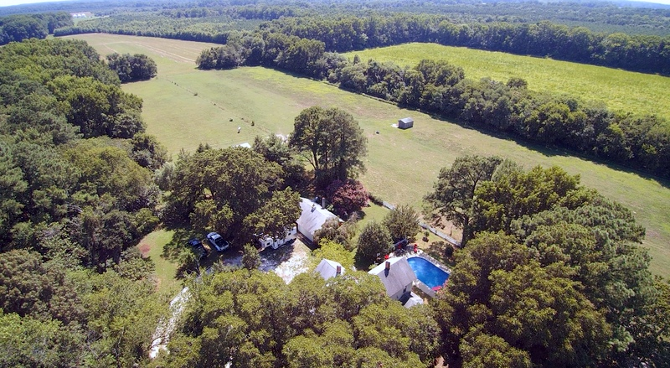
6088 Cobbs Station Road Cape Charles Virginia 23310

PERFECT LANDING FARM is situated on 40 acres outside of Cape Charles, just 35 min. from Norfolk and 12 minutes from the Bay Bridge, This classic Eastern Shore farmhouse was built in 1926 and boasts its own 1800’ air strip, identified as "Eagle's Nest Airport" on FAA maps.

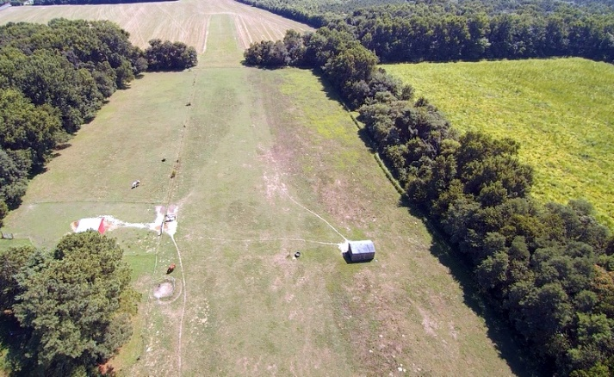

The farm is also an equestrian property with approximately fifteen acres of fenced and well maintained pastures divided into multiple paddocks for grazing rotation. The paddocks have water in each pasture as well as electric to plug in water heaters in the winter. Additionally, there are two run-in sheds, a wash rack, a grooming station and a small tack/feed barn with electric and lighting for storage. Two apple trees in the back yard ensure your equine friends will gather at the pool gate in the summer to visit - and also ask for a treat. There are multiple ride-out possibilities both on and off-property and the Eastern Shore hosts an organized trail ride twice a year for beach riding enthusiasts.
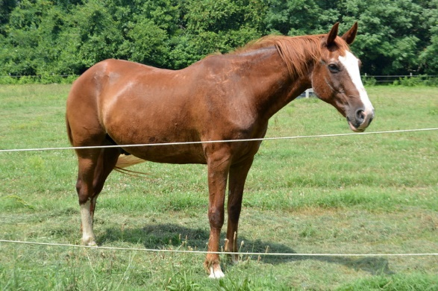
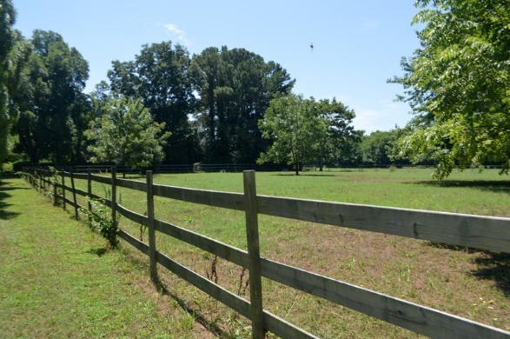

The 1926 farmhouse has 2,008 sq feet of living space and was built to last.

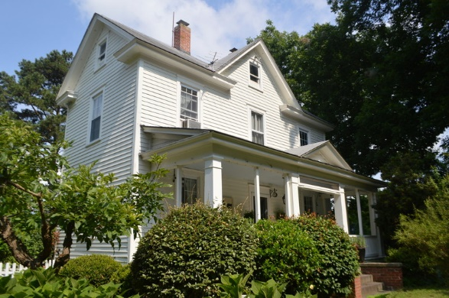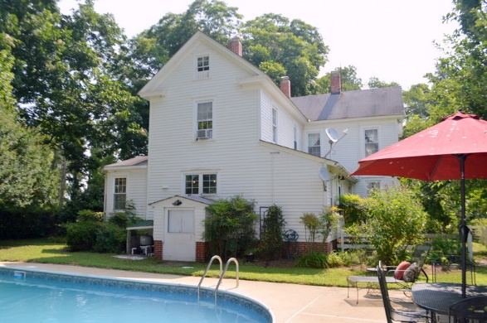

Inside the house, the kitchen was redone in 2015 with white cabinets and molding, honey-colored wood countertops, a large porcelain farmhouse sink, antique bronze faucet, new cabinet hardware and new light fixtures. The kitchen island was also re-worked with a light fixture/ and antique bronze pot rack, new countertop and generous storage underneath. The kitchen is painted Benjamin Moore paints "Butter". Custom window treatments and matching settee add a bright warmth and coziness to the space.

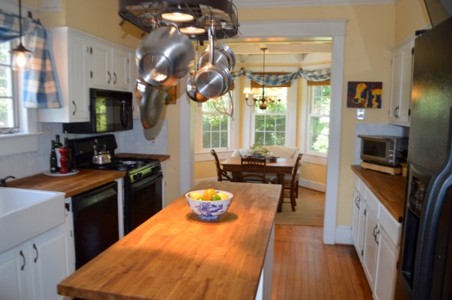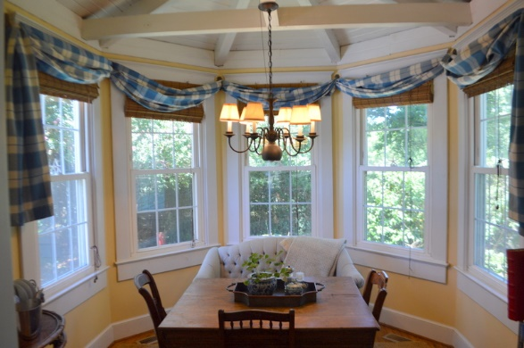

The 1st floor parlor can easily become a bedroom. There is a bathroom right outside the door.
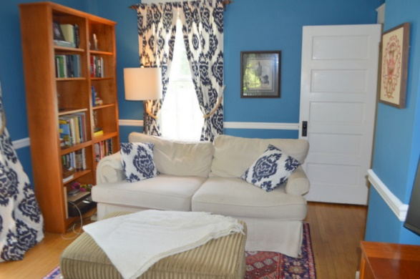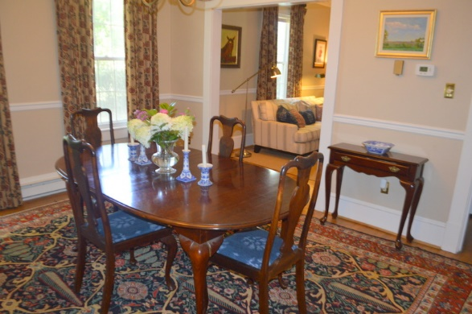

The downstairs living spaces and bathroom were all freshly painted in 2016 with Benjamin Moore paints. The home is furnished with a mix of antiques, antique reproductions and custom pieces. The upholstery and drapes were custom made in Calico Corners fabrics in shades of marine blue, incarnadine red, beige and cream. Coordinating fabrics are mixed throughout the house, carrying over the Provincial farmhouse charm. The result is a sophisticated mix of rustic and classic design elements that balance the classic farmhouse lines with an updated and more modern feel. It is possible that owners will negotiate furniture if a buyer is interested.
A mud room was added to the side of the house.
Every farmer needs one.

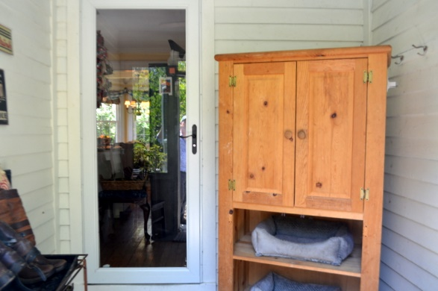
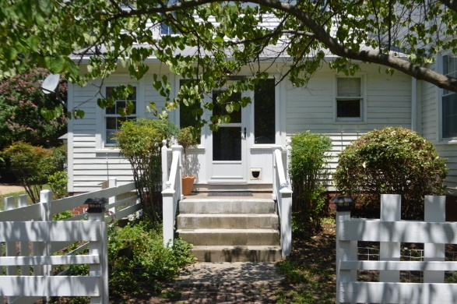
The farm is a very welcoming place for pets and comes with a completely enclosed, dog-safe yard surrounding the house, a recently enclosed back porch with heater and cat door as well as a tree house (with bell!) hidden in the leaves for the feline

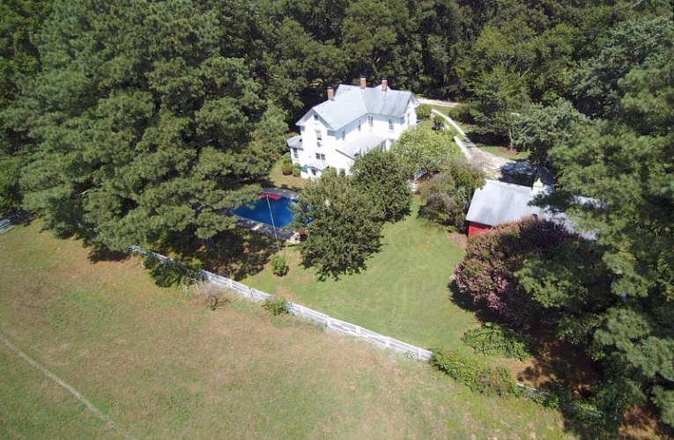

The home's grounds and garden boast mature plantings of hydrangea, lilac, gardenia, rose, azalea, crepe myrtle, forsythia, daffodil, lilies, tulips, cyclamen, pear, apple and fig trees and a small grapevine that produces the tiniest, sweetest grapes. There is always something in bloom and the options for fresh cut flowers are endless. There are two gardens, a small kitchen garden near the back door of the house and a larger, irrigated garden with found raised boxes, electric and water connections nearby. The current owners designed and installed an arbor entrance to the front yard, complete with jasmine climbing the trellis arch. The smell from the front porch is that of a tropical oasis.
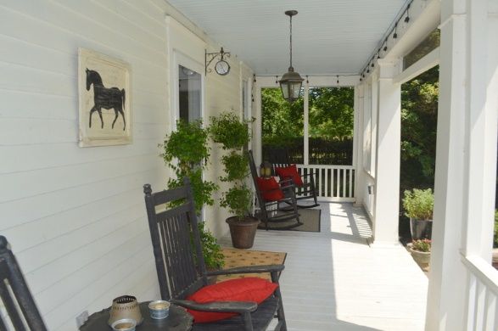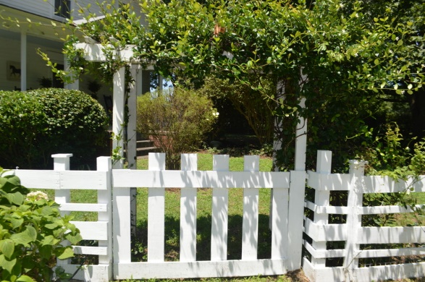

THE CURRENT OWNERS SHARE THEIR IDEA OF A PERFECT DAY ON PERFECT LANDING FARM:
Imagine waking up to the sights and sounds of the countryside: birds singing and the sun peeking through the windows as it rises in the East over the water less than a mile away.
Wander out to chicken coop to collect farm fresh, free-range eggs, then to the irrigated garden for fresh herbs and flowers. Cook your eggs sunny side up in the updated kitchen complete with newer appliances and all modern conveniences, curl up in the sunny breakfast nook to read the paper or take your coffee out onto the front porch, redone in 2012, and relax in the rocking chairs while you check e-mail and listen to the sounds of the countryside waking up.
Then go for a ride on your best buddy, stabled on-property or pop into town for lunch and a quick look at the local art galleries. After lunch, visit more shops or swing by the farmer's market to pick up fresh fruits, veggies and breads for dinner.
In the afternoon, take a hop in your plane over the Eastern Shore to watch the farmers and watermen hard at work and marvel at the beauty of the Chesapeake in all its sun soaked glory.
After you land, stop by Shooting Point Oyster Co. for fresh oysters by the case and Chatham Vineyards for the perfect Chardonnay to pair with them. Invite friends over, grill the oysters and enjoy dinner al fresco on the patio by the pool.
After everyone leaves, watch the sunset light up the sky while swimming in your oh so private pool. In the fall, gather everyone around a fire in the fire-pit with mugs of hot chocolate to watch for shooting stars and tell stories after the local oyster roast. Truly, life doesn't get much better than this.

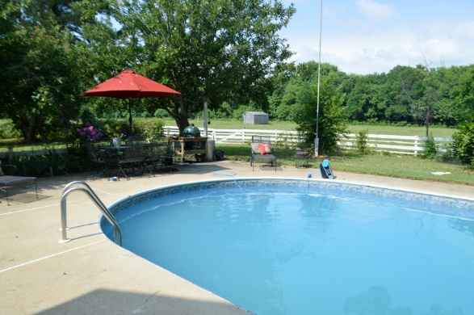

OR: If horses don’t appeal, skip the horses and start a vineyard or an organic farm. Sunflowers anyone? Stomp around in your 12 acres of woods. Tinker in your oversize garage. Or just enjoy the incredible privacy and laze by your pool.
Come See For Yourself All the Joys and Possibilities of
PERFECT LANDING FARM.

